Infosys Springboard Virtual Internship 6.0 Completion Report

# Team Details

Batch Number: 4

Start date: 13th-Oct-2025

Names:

|  |
| --- |
| AKASH B |
| Bhanu prasad babu Bellala |
| Bhuvaneshwar |
| Boddu Haripriya |
| Cheepurupalli Ekshitha |
| GANESHPRABHU S |
| Gourishetty Rishitha |
| Harsh Kumar |
| Jayashree K |
| Kalash Srivastava |
| KATRAVATH HARSHAVARDHAN |
| KEERTHANRAJ B |
| Mathunithaa P L S |
| Mohammed Noushin Saher |
| NADISH SENTHIL |
| Payal Sahu |
| Raina Fatimah |
| Sagarika Naik |
| SATHYA SREE PUTHETI |
| Sontanam V C M Bhavani Sundari |
| Soumyajit Rout |
| Sri Sai Prasanna Chinnam |
| Swaranthi Balamurugan |
| V Veeresh |
| Vaishnavi Ambhore |
| Yamini Gottapu |

Internship Duration: 8 Weeks

# 1. Project Title

NeuroFleetX - AI-Driven Urban Mobility Optimization

# 2. Project Objective

The main aim of the NeuroFleetX project is to apply AI to improve the urban mobility system. It aims at optimizing traffic flow, reducing congestion, and improving transportation efficiency by enabling intelligent data analysis and predictive modeling. In other words, NeuroFleetX develops smarter, more sustainable, adaptive urban transport networks through the integration of AI-driven insights for dynamic responses to real-time conditions.

# 3. Project description in detail

NeuroFleetX represents an innovative approach to how cities can reshape urban mobility by embracing artificial intelligence. Advanced data analytics are merged with machine learning algorithms and predictive modeling, creating intelligent systems that can manage and optimize transportation within urban centers. By examining real-time traffic flow, vehicle movement patterns, and commuter behavior, NeuroFleetX empowers cities to reduce congestion, enhance safety, and streamline travel. The ultimate outcome is the crafting of a sustainable, adaptive, and efficient ecosystem of mobility that answers the changing needs of modern urban settings.

# 4. Timeline Overview

|  |  |  |
| --- | --- | --- |
| Week | Activities Planned | Activities Completed |
| Week 1 | Complete a Landing Page with proper UI | Completed a Landing Page |
| Week 2 | Create login pages for 3 portals | Created a login page for the first portal |
| Week 3 | Create a Fleet Manager Portal | Created the remaining login pages |
| Week 4 | Create a Driver Portal | Created a Fleet Manager Portal |
| Week 5 | Create a Customer Portal | Created a Driver Portal |
| Week 6 | Connection to all the Portals by routing it each other | Created a Customer Portal and Routed all the pages |
| Week 7 | Solving errors found in the project | Solving the error found in the project |
| Week 8 | Completion Work, Powerpoint work | Completion Work, Powerpoint work done |

# 5a. Key Milestones

|  |  |  |
| --- | --- | --- |
| Milestone | Description | Date Achieved |
| Project Kickoff | Understanding what is NeuroFleetX | 16th-Oct-2025 |
| Prototype/First Draft | Created Dashboard for the Fleet Mananger | 23rd-Oct-2025 |
| Mid-Term Review | Created a Dashboard for the Driver | 16th-Nov-2025 |
| Final Submission | Created a Dashboard for a customer | 30th-Nov-2025 |
| Presentation |  |  |

# 5b. Project execution details

NeuroFleetX is an AI-based system to optimize urban mobility by decreasing congestion and enhancing fleet operations with the use of real-time data and machine learning. The project is full-stack, featuring React 18.2.0 in the frontend and Spring Boot (Java) on the backend, with MongoDB as the NoSQL database. Key dependent packages on the frontend include React Router DOM, Framer Motion, Tailwind CSS, Material UI, Axios, Chart.js, Leaflet, and Mapbox GL. The project uses Maven to manage backend dependencies and npm to manage the frontend packages. To execute the system, run npm install then npm start for the frontend at localhost:3000, and ./mvnw spring-boot:run for the backend at localhost:8080.

6. Snapshots / Screenshots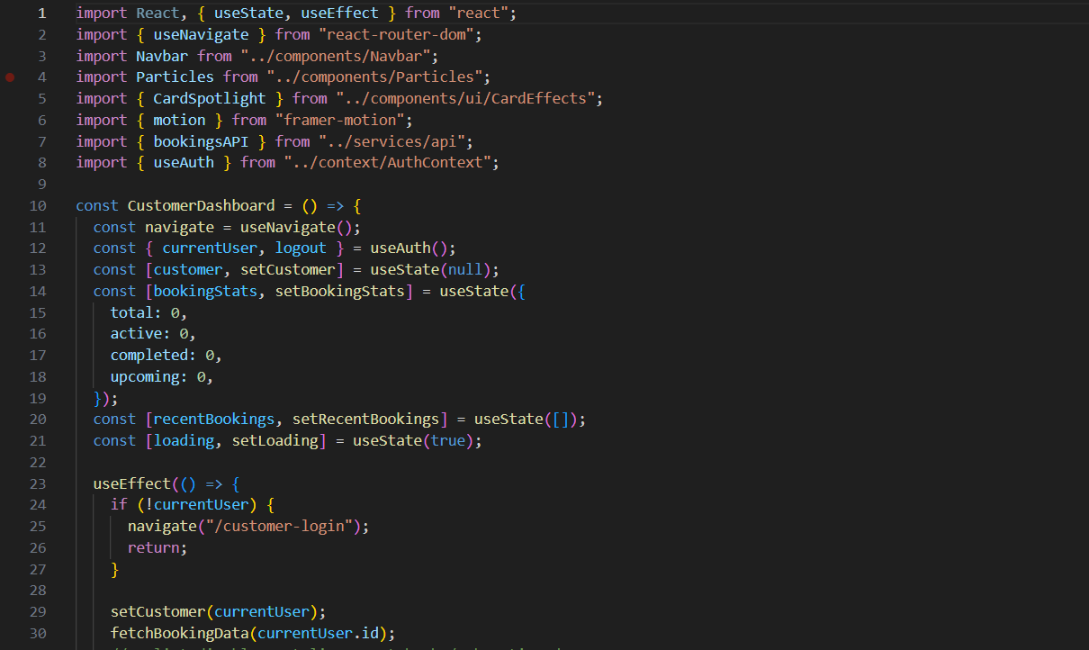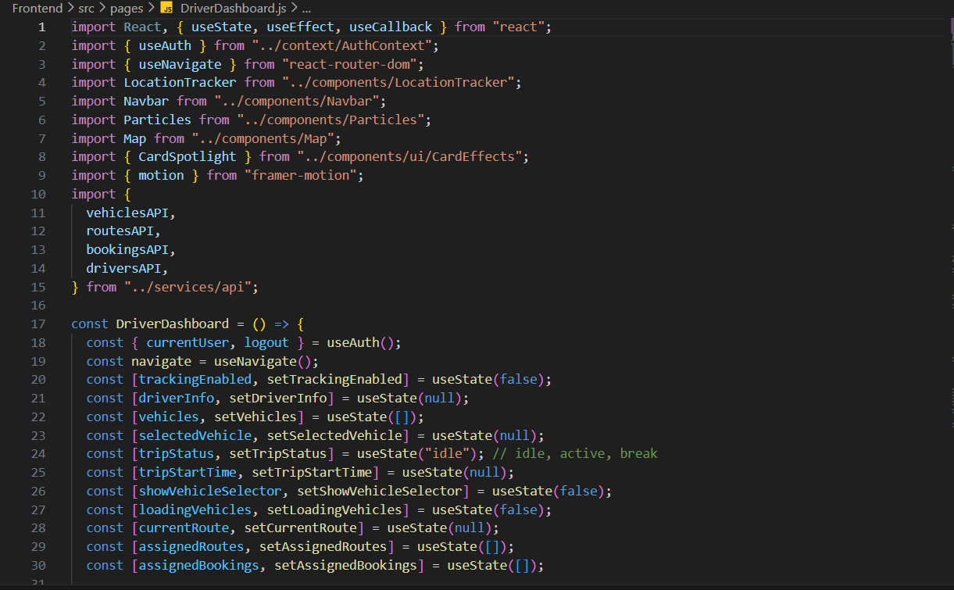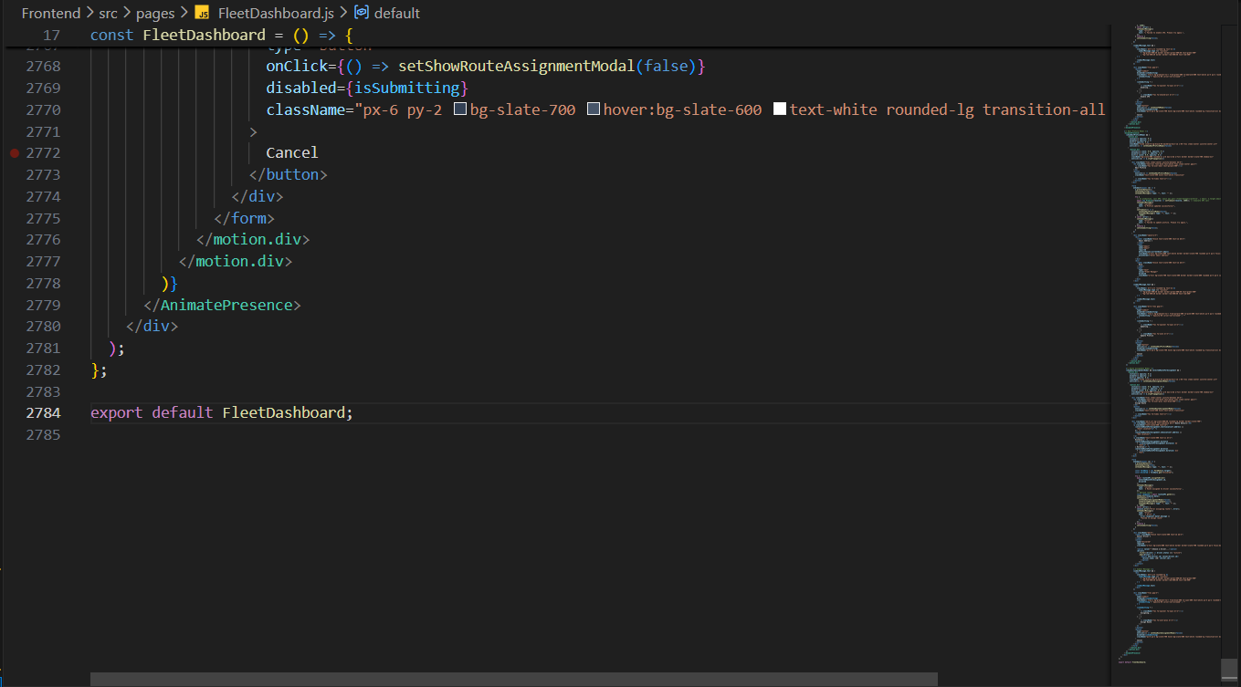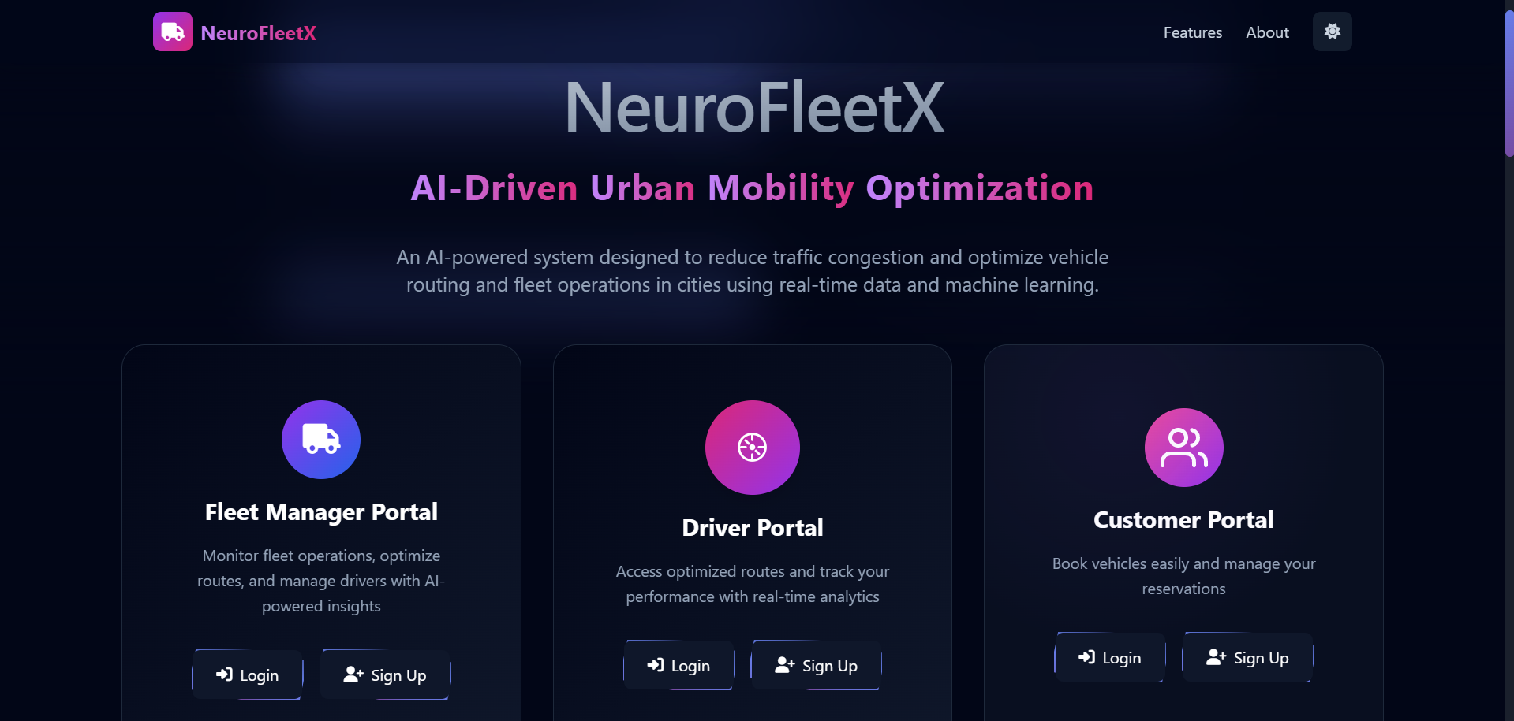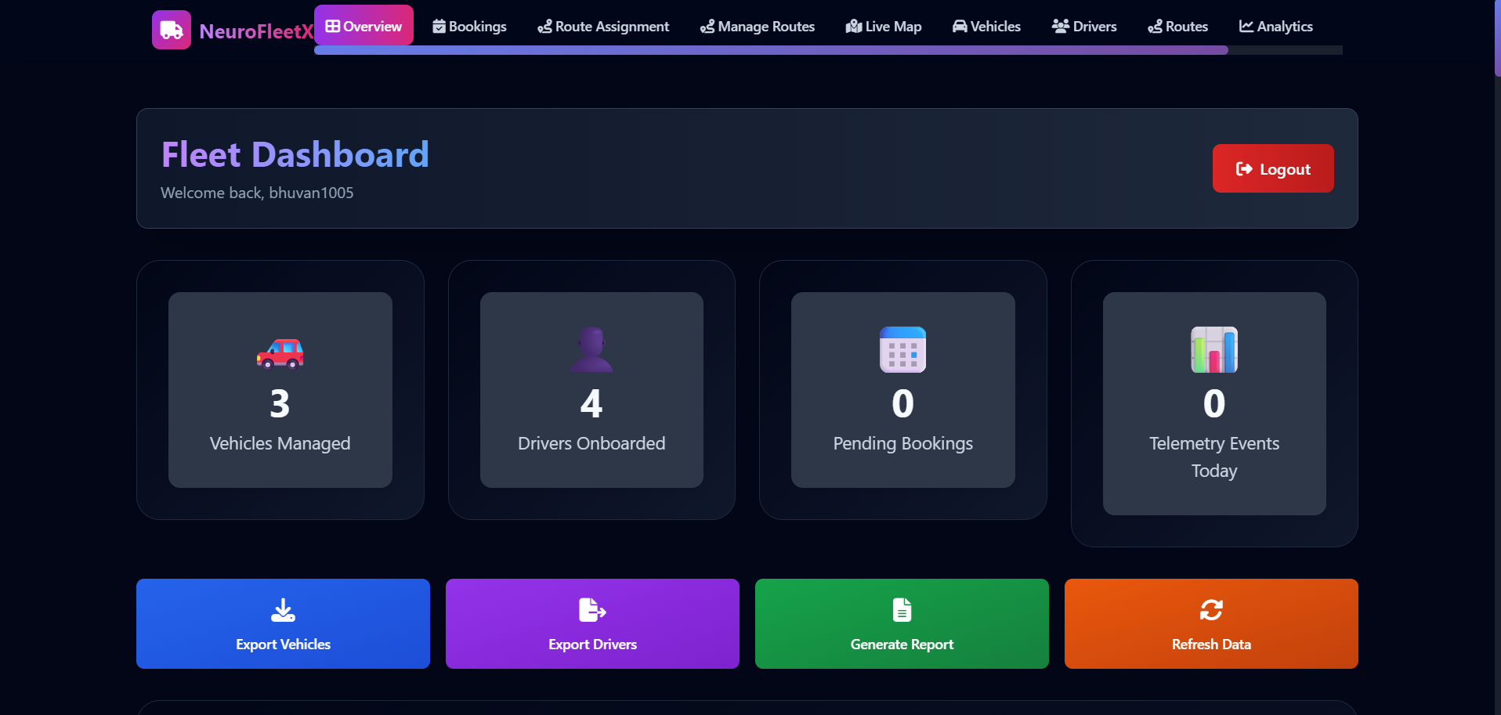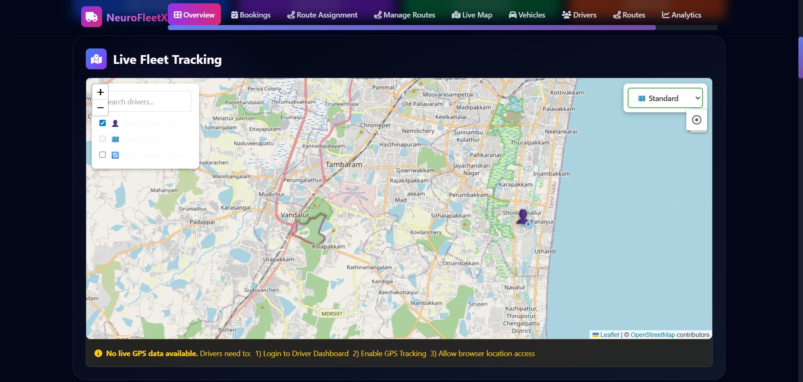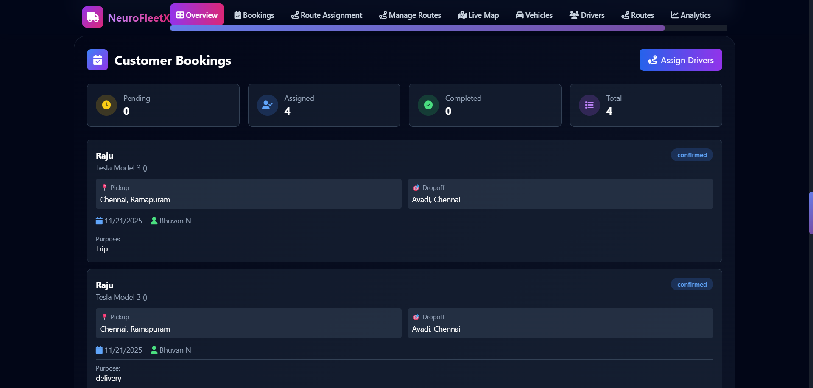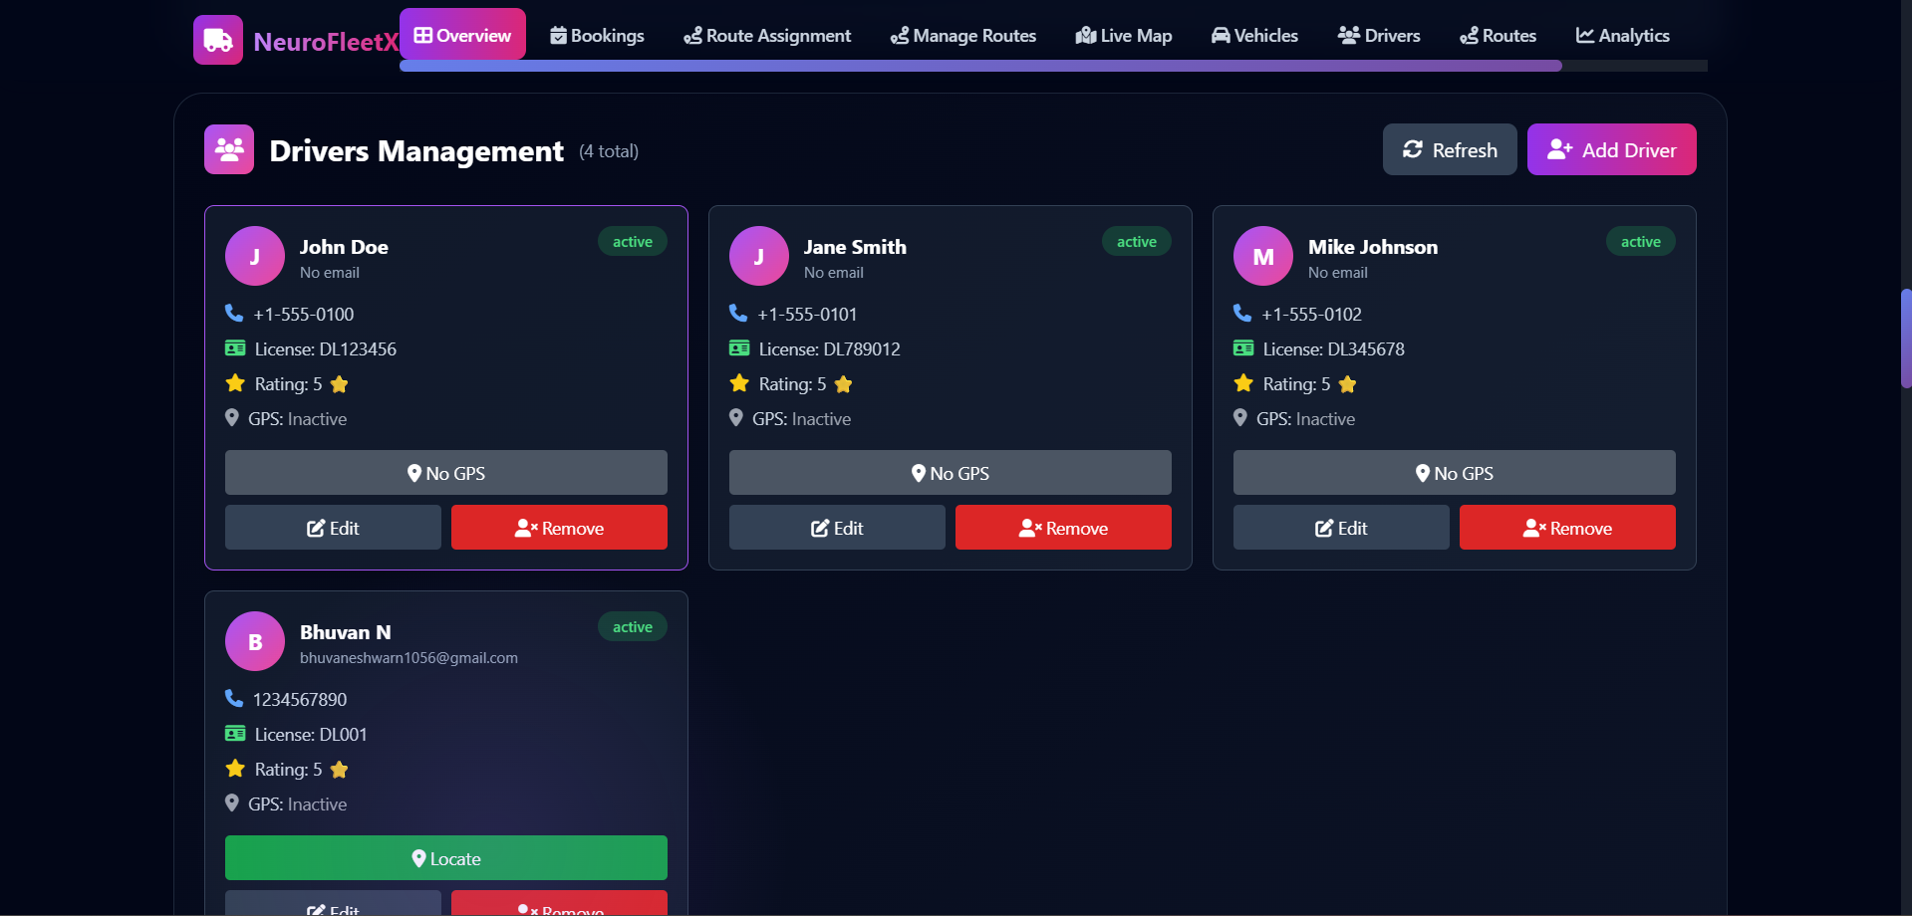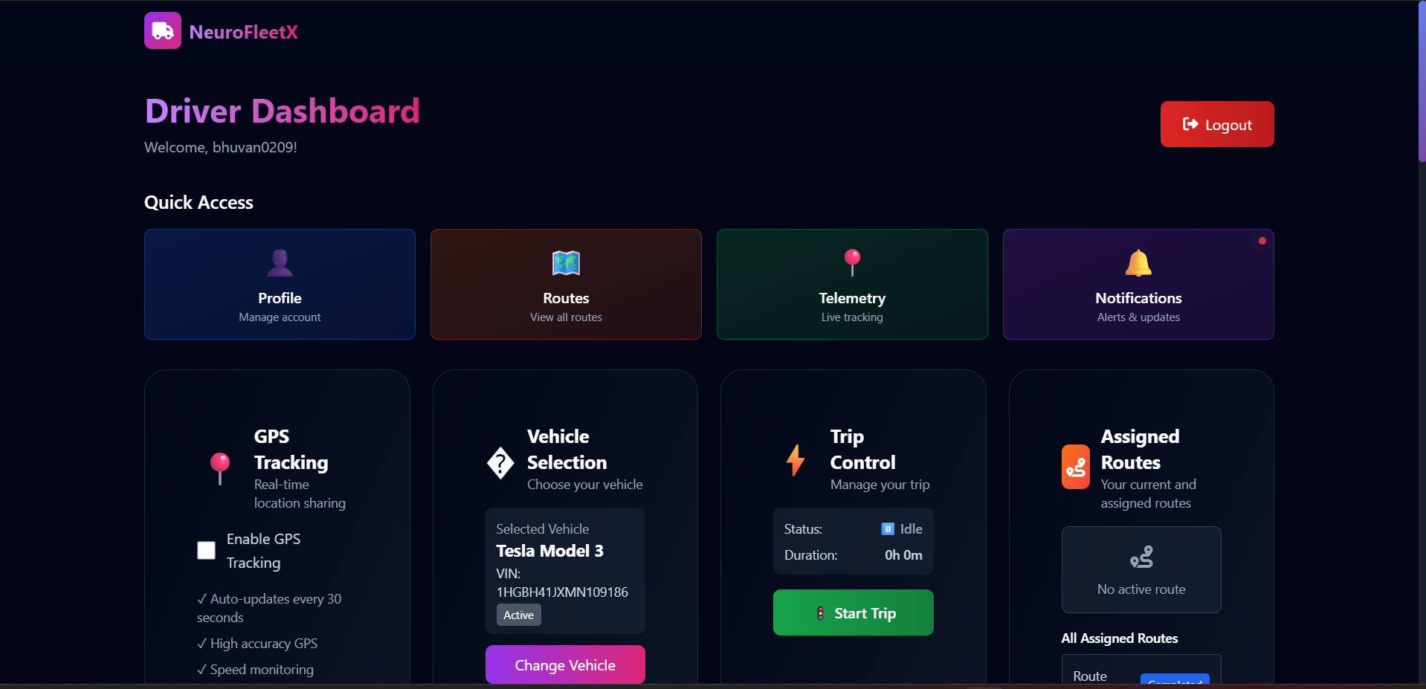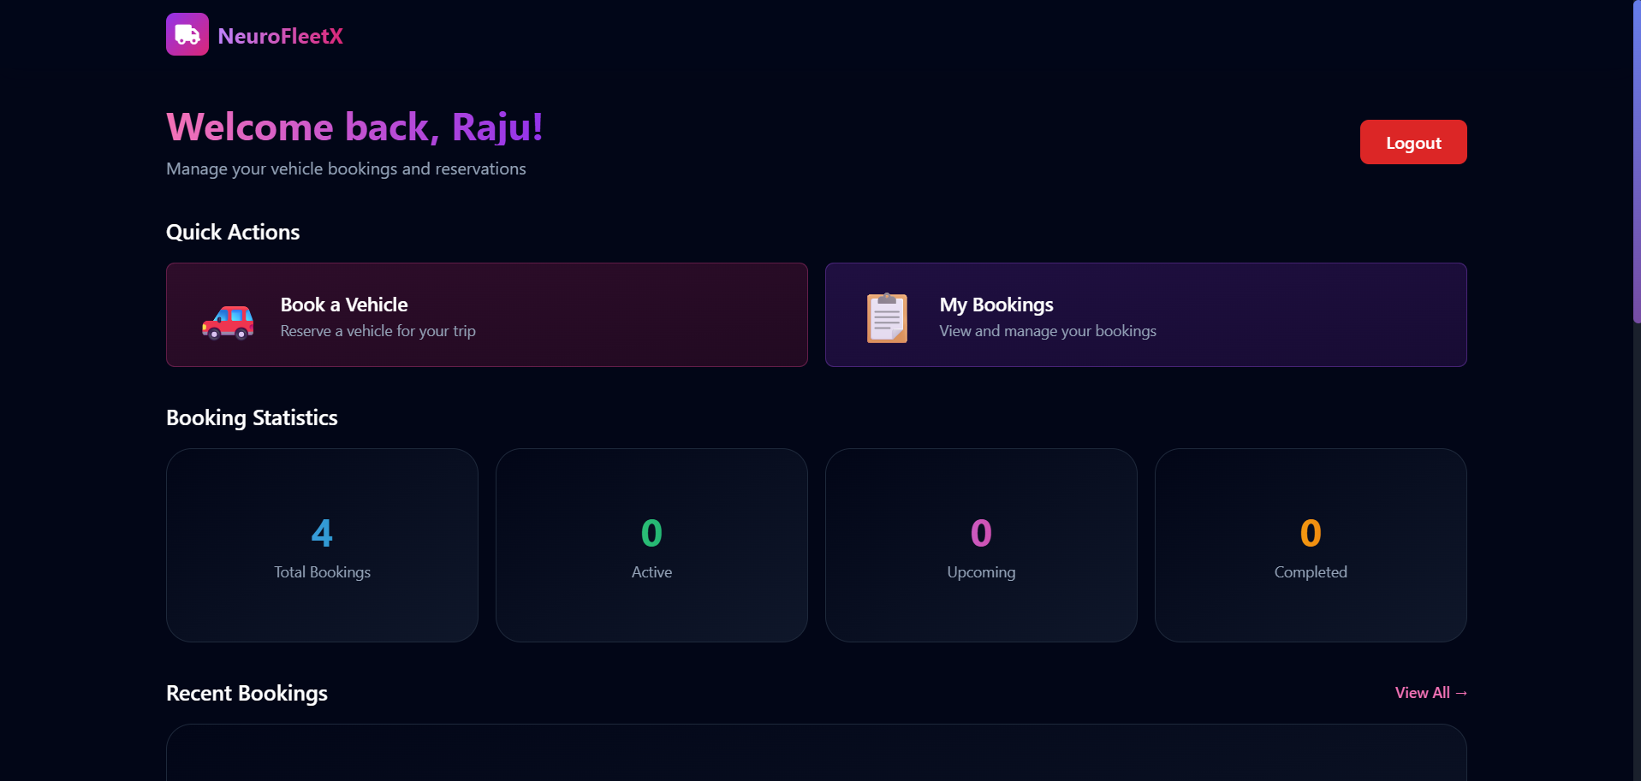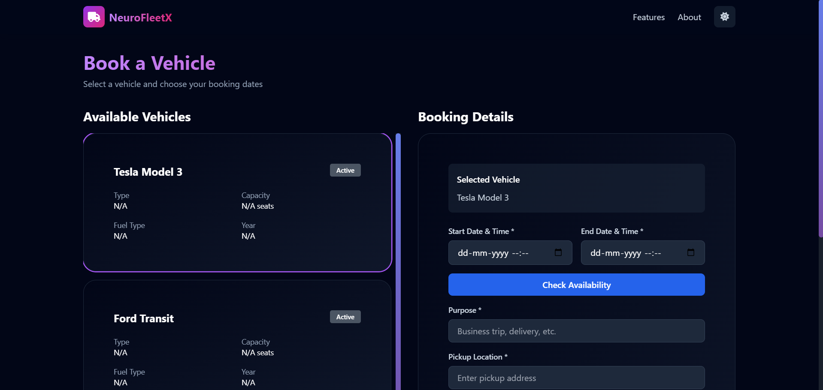

# 7. Challenges Faced

The NeuroFleetX project also presented a number of challenges because of its complex full-stack setup: React, Spring Boot, and MongoDB. Handling complex asynchronous data flows, solving CORS-related problems, and maintaining consistent data models were not easy, especially when many real-time features, like vehicle tracking and route optimization, required high performance from APIs and databases. The integration of AI was required for predictive analytics and maintenance, considering model accuracy and real-world validation. Security concerns included the implementation of role-based authentication, encryption, and GDPR compliance. Optimizations of the UI/UX, performed with Framer Motion and Tailwind CSS, were necessary to avoid lag on low-end devices. Complexity related to scalability and deployment across multiple environments added additional challenges. Besides this, the limitation in testing tools made the validation of AI-driven logic time-consuming. Possible issues of dependency management and resource constraints further influenced development speed and stability.

# 8. Learnings & Skills Acquired

By developing NeuroFleetX, I had very strong full-stack development experience through the integration of React for responsive interfaces, Spring Boot for backend services, and MongoDB for data management. This included building RESTful APIs, authentication handling, and database optimization for real-time performance. On the frontend, with React Router, Axios, Framer Motion, and Tailwind CSS, I created dynamic, efficient UIs. The project further developed my use of Git, npm, and Maven, debugging related to integrating the technologies when issues arose, such as CORS or desynchronization of data. It further enhanced my collaboration and time management, whilst deepening an understanding of AI-driven urban mobility, route optimization, and predictive analytics. Overall, the project enhanced my technical capability and reinforced the importance of building scalable, user-focused, and ethical software.

# 9. Testimonials from team

Working on the NeuroFleetX project was a highly rewarding experience that strengthened my full-stack development skills and deepened my understanding of AI-driven urban mobility solutions. I gained hands-on experience integrating React, Spring Boot, and MongoDB to build a scalable, data-driven system while tackling challenges like real-time synchronization, API optimization, and security implementation. The project also enhanced my problem-solving, teamwork, and time management abilities, reinforcing the importance of building efficient, user-focused, and sustainable software solutions for smart city applications.

# 10. Conclusion

The NeuroFleetX project successfully demonstrated how artificial intelligence can be leveraged to optimize urban mobility through real-time data analysis, predictive modeling, and intelligent route management. By integrating a robust full-stack architecture with modern technologies such as React, Spring Boot, and MongoDB, the system achieved scalability, efficiency, and reliability across multiple user roles. Despite technical challenges, the project enhanced the team’s expertise in full-stack development, AI integration, and collaborative problem-solving. Overall, NeuroFleetX stands as a step forward toward creating smarter, data-driven, and sustainable transportation solutions for future urban environments.

# 11. Acknowledgements

I would like to express my heartfelt gratitude to Infosys for providing me with the opportunity to work on the NeuroFleetX project as part of my internship. This experience has been invaluable in enhancing my technical knowledge, professional skills, and understanding of real-world software development practices.I extend my sincere thanks to my mentor, Mr. Senthil, for his continuous guidance, encouragement, and support throughout the project. His expertise, constructive feedback, and insightful suggestions played a crucial role in shaping the success of this work. I am also thankful to my teammates and everyone at Infosys who contributed directly or indirectly to the successful completion of this project. This journey has been a truly enriching and memorable learning experience.